Chapter 1: Introduction to Machine Principles

  - Electromagnetic field
Magnetic Fields (MF) are mechanisms for energy conversion from one form to another i.e. in transformers, motors, generators… etc. Four basic principles describe how magnetic fields are used in these devices:
It is a must to establish a magnetic field before the conversion process
- A current-carrying straight wire produces a magnetic field in the area around it.

Right hand rule (R.H.R.)
direction of the
magnetic field Conductor perpendicular to the plane.

I get a series of concentric circle of magnetic lines around the conductor.
- A time-changing magnetic field induces a voltage in a coil of wire if it is located in the field (this is the basis of transformer action )
ф
I It should be AC to have a MF

Magnetic core
Mean path length (l_{c})
- A current –carrying wire when subjected to a magnetic field will experience a force acting on it (This is the basis of motor action)

When there is a current interaction Magnetic bar is current
interaction

- A moving wire when subjected to a magnetic field has a voltage induced across its terminals (this is a basis of generator action)

  - Production of magnetic field:
The basic law governing of Magnetic Field is by Ampere’s law

$\int{Hdl}$ =I_{net}

I_{net} : current (A)
$$dl:mean core differential length element$$
H: magnetic field intensity (Amp.turns/m)

For better understanding of the formula we have a rectangular core with a winding of N turns around one leg. Consider all the field remains in the core:

Ф

I

Only mean core
Length (l_{c})

When an alternating current passes by this coil we have a flux produced in Weber.

NI=Hl_{c}

Nl: Ampere Turns produced
H: Magnetic Field intensity
l_{c} : mean core length(path)

Ф: is the flux produced
How much magnetism I have in the wire
B flux density (Wb/m² or Tesla) = $\frac{ф(wb)}{A}$
A: the net cross sectional area (m²)

B=µH
B (Tesla or wb/m²): Flux density
µ: Permeability: the ability of the core medium to be magnetized
H: Magnetic field intensity
µ = µ_{r}µ₀
µ₀= 4π×10⁻⁷ H/m (in free air)
for air µ_{r}=1.0
µ_{r} can reach up to 6000 for certain materials.
B= $\frac{µNI}{l_{c}}$
Ф= BA= $\frac{µNIA}{l_{c}}$
  - Magnetic circuits:
paths for magnetic flux.

- Flux lines never intersect
- Flux lines follow paths of permeability (least reluctance to magnetism)
- Once a loop is established ф is constant in it

I ф

EMF
R

R (reluctance)

V=iR mmf=Ni

mmf = NI
magnetomotive force ф = F/R
permeance = 1/R

Ф = F×P
Ф = µNIA/l_{c}
- Ф = F(µA/l_{c})
R (reluctance AT/wb) = l_{c}/µA for a single medium to be magnetized AT/wb
  - Composite magnetic circuits

Ф constant (if A changes and B changes)

R_{Ag} = g/A_{g}µ₀ ф
A_{g}: Area of the gap
Ni_{g} Fringing effect at air gap i.e. A_{g} increases

R_{core}= l_{c}/µA_{core}
R_{air gap}= g/µ₀A_{g}

The cross sectional area is increased which leads to a decrease in flux density. When we neglect fringing effect the flux density remains constant.

NB.As the flux is constant in a loop, when the cross sectional area changes the flux density changes.
Series elements in magnetic circuits
When elements are connected in series, then the total reluctance is the sum of individual reluctances of the elements.
R_{AC1}
$$ф$$
$\sum{Hl=H_{c1}L_{c1}+H_{c2}L_{c2}+H_{g}L_{g}}+…$
$= \frac{B_{c1}l_{c1}}{µ}+\frac{B_{c2}B_{c2}}{µ}+\frac{B_{g}l_{g}}{µ}+…$
R_{g}
R_{AC2}
$ф\left[\frac{l_{c1}}{µA_{c1}}+ \frac{l_{c2}}{µA_{c2}}+ \frac{l_{g}}{µA_{g}}+…\right]$
$= ф\left[R_{c1}+ R_{c2}+R_{g}+…\right]$
The total reluctance of elements that are in series is equal to the sum of individual reluctances.
NB. B varies when the element area varies.
Parallel elements in magnetic circuits:
$$\frac{1}{R_{T}}= \frac{1}{R_{c1}}+ \frac{1}{R_{c2}}+ \frac{1}{R_{g}}+ …$$
ф
Ni
R_{AC1} R_{AC2} R_{g}

Example:
An iron ring of square of 2×2 cm cross sectional area having an external diameter of 14 cm and an internal diameter of 10 cm. A radial saw cut through the ring forms an air gap of 1 mm. If the ring has a coil uniformly wound round it. With 500 turns calculate the current in the wire of the coil required 1mm to produce a flux of 3.5×10⁻⁴ Wb in the Air gap. Neglect flux leakage and fringing.

1mm

14 cm

10 cm

B(tesla) | 0.65 | 0.89 | 1.06 | 1.18
H(AT/m) | 200 | 300 | 400 | 500
The values are:

Total mmf = H_{c}l_{c} + H_{g}l_{g}
l_{c} = πD_{mean} =$π$ $\left[\frac{10+14}{2}\right]=0.0376 m$
$A_{c}=2×2×{10}^{-4 }m^{2}=4× {10}^{-4}m^{2}$
Plot of Graph
$B=\frac{ф}{A}= \frac{3.5×{10}^{-4}}{4×{10}^{-4}}=0.875$
B(tesla)
$H_{core}=295{AT}/m$
0.875
$H_{c}l_{c}=295×0.376=111.21 AT$
$B_{g}=µ_{0}H_{g}=> H_{g}=\frac{0.875}{4π×{10}^{-7}}=696302 {AT}/m$
H AT/m
$H_{g}l_{g}=696.3$
$Total mmf= H_{c1}l_{c1}+H_{g}l_{g}=807.12$
295
$$NI=807=>I=\frac{807}{500}=1.61 amp.current required$$

2. A uniform area core of 25$×25$ mm² has the following shape
Ф₁ ф₂

i Ф₃
lg₁=0.5mm lg₂=1mm

i = 0.25 A N= 1000 Turns
µ_{p} of $core=∞$therefore Rc =0
Calculate ф and B in each leg.
The only source of reluctance is in the gaps.
Ag₁ = Ag₂ = 25×25×10⁻⁶
$$Rg_{1}=\frac{\lg_{1}}{µAg}= \frac{0.5×{10}^{-3}}{µ_{0}Ag}=\frac{0.5}{4π×{10}^{-7}×25×25×{10}^{-6}}=0.6355×{10}^{6}{AT}/{wb}$$
$$Rg_{2}=\frac{\lg_{2}}{µAg}=1.273×{10}^{6}{AT}/{wb}$$
$$ф_{1}=\frac{F}{R_{1}}=\frac{0.25×1000}{0.6366×{10}^{-6}}=0.3927 mWb$$
$$ф_{2}=\frac{F}{R_{2}}=\frac{0.25×1000}{1.273×{10}^{-6}}=0.1963 mWb$$
$$ф_{3}= ф_{1}+ф_{2}=0.589 mWb$$
$$B_{1}=\frac{ф_{1}}{{Ag}_{1}}=\frac{0.3927×{10}^{-3}}{25×25×{10}^{-6}}=0.628 T$$
$$B_{2}=\frac{0.1963×{10}^{-3}}{25×25×{10}^{-6}}=0.314 T$$
$$B_{3}=\frac{0.589×{10}^{-3}}{67.5×{10}^{-6}}=0.942 T$$

  - Faraday’s law
If a flux passes through a wire, therefore a voltage (emf) will be induced. This voltage is proportional to the rate of change of the flux.

$emf\left(e\right)=-\frac{dф}{dt}$
N S

The emf induced in a loop of wires with N-turns; therefore the emf induced is:
$$emf\left(e\right)=-N\frac{dф}{dt}$$
Lenz’s law gives us the sign needed of the voltage induced which represents the direction of the emf induced.
This sign is obtained as follows:
If the coil is short-circuited at its terminals a current will flow.
This current will produce a flux opposing the original flux of the coil.
Self-inductance
The self-inductance of a coil affects its ability to stop changes in the corresponding magnetic field.
Flux linkage: The flux that is cutting the coil. (Maximum flux linkage of a coil with N turns coils)
$$λ=N×ф$$

$$B(Tesla)=\frac{ф(wb)}{A(m)}$$

$$ф=BA$$
$B=µH$
$$magnetic intensity B=\frac{µNIA}{l_{c}}$$
$$µ: permeability$$
$$l_{c}: mean length of core$$
$$λ=\frac{µN^{2}IA}{l_{c}}$$
$$L=\frac{λ}{i}=\frac{µN^{2}A}{l_{c}}$$
$$L_{Ag}=\frac{λ}{i}=\frac{µ_{0}N^{2}Ag}{l_{c}} in air gap$$
The energy stored in the magnetic circuit.
$$P=ei=i\frac{dλ}{dt}$$
Work done equals to energy stored $:$
$E_{0}S_{0}=\int_{0}^{t}{Pdt}$
$$=\int_{0}^{λ}{idλ}$$
$$=\int_{0}^{λ}{\frac{λ}{L}}$$
$$=\frac{1}{2}\frac{λ^{2}}{L}$$
$=\frac{1}{2}LI^{2} \left(Joules\right)$by replacing $λ^{2}by L^{2}i^{2}$

Example:
A 2 pole shunt motor has a flux per pole 0.01 Wb when the exciting-current is 2 A the number of turns in each pole equals 2000. Calculate the energy stored in the magnetic field.
Find L and then ф then the flux linkage.
Ф = 0.01 Wb
I field
Supply Armature

Number of turns =2×2000= 4000 we have 2 poles
$$L=\frac{λ}{i}=\frac{Nф}{I}=\frac{4000×0.01}{2}=20 H$$
The energy stored is magnetizing the field so the motor functions.
$Energy stored= \frac{1}{2}LI^{2}=\frac{1}{2}×20×2^{2}=40 J$

  - Characteristics of ferromagnetic material

Important in the transformation of energy.
Magnetic circuit is a necessity but it has losses for the same B=µH
If µ increases H will decrease

Those with high permeability materials are more expansive than the ones with low permeability.
With higher µ_{r} we obtain small H, hence less magnetizing current i.e. lower losses.

$$µ_{0}=4π×{10}^{-7}$$
µ_{r} can go up to 6000 when changing from one material to another.

Magnetic behavior of ferromagnetic materials:
In electromechanical energy conversion devices, these materials have 2 important roles to be played:

- From B=µH, we have to obtain large B from smaller levels of H; as µ increases H will decrease . Large B leads to an increase in the magnetic forces and energy density. This plays a major role in the performance of energy conversion devices. When we decrease H=NI/l, as H decreases I will decrease.
- Magnetic materials can be used to constrain and direct magnetic fields in a well defined path i.e. in a transformer, it maximize the coupling λ between windings and lower I excitation for transformer operation. In rotating machines they shape the field to obtain the desired torque characteristics. Ferronmagnetics are iron, iron alloys with silicon, cobalt, mg, nickel etc…
µ₀ is constant; µ_{r} varies up to 6000 µ₀

saturation
B Tesla
knee

linear
H (AT/m)

The field is more contained in the magnetic material we have less leakage and better λ and hance smaller excitation I is needed or lower N (number of turns)

In the machines the torque is affected greatly by the magnetic field therefore we have:
- How to decrease a B H curve? B
i decrease (1)
- Have magnetic material
- coil has N turns core length
- increase the current
- coil is fully unmagnetized reverse the current (2) increase i

H AT/l

(4) The hysteresis loop
(3)
saturation

From (1) (2) we start to decrease the current, B doesn’t follow the same path because the core is magnetized. (Residual flux or magnetism) Then at (2) we reverse the direction of the current and start increasing it until saturation. It will produce a magnetic field in the opposite way to (3)
At (3) we start decreasing that current until it reaches 0 value at (4)
At (4) we reverse the current and start increasing it until saturation reaching (1)

The hysteresis loop is the representation of the loss which has to be taken care of. This loss is due to the formation of flux.
The smaller the hysteresis loop for the material the smaller are the losses hence the better material.

$$P_{H}=K_{h}fB_{max}V$$

$K_{h}: Constant for the material$
$f: frequency(Hz)$
$B_{max}: max flux(T)$
$V: Volume in m^{3}$

Flux density varies between 1.5 2.5
For cast-steel flux density= 0.025

The hysterisis losses are proportional to the frequency and not linearly proportional, the ability of the material to be magnetized.
P_{e} (eddy current losses) due to emf induced in the core itself which will cause circulating current in it which results in any current losses
To minimize these losses: of the core increase R by lamination in thin sheets insulation these sheets from each other then I tight them. Any current losses formula:

$i^{2}R=\frac{V^{2}}{R}$
V: induced emf
R: Electric resistance of the core

$$Φ_{e}=K_{l}f^{2}B_{max}^{2}$$

K_{l}: Constant of material
f: frequency
B_{max}: Flux density
A group of e⁻ that has certain magnetic direction form the domain

  - Magnetic domains

This happens due to an mmf they are being lined up.
The alignment ends at the saturation, any addition is a waste.
We need the domain to be aligned. Any extra mmf will be a loss.
The hysteresis losses are used to produce theses domains> I want them aligned to produce the magnetic field.
Ampere-turn is used to align them.

  - Motor and generator action due to magnetic field

Motor action:

Assume we have a magnetic field and in the surrounding then it will induce a current-carrying conductor which will produce a force.

If a current I is flowing B
F (force)
$F=i\left(L×B\right)$
I
L: length of conductor
B: Flux density conductor
$\left(L×B\right) vectorial$
N.B. in series magnetic circuit ф is constant; B is not necessarily constant if we have composite circuits with different cores if we consider fringing A changes.
$F=ilB\sin{Ѳ}$
$$Ѳ: angle between wire and flux density$$
Generator action:
Induces an emf and then current. V B
Induced voltage in a conductor +++
Moving in a magnetic field
No movement no emf induced L
B: flux density ___
V: velocity of the wire
L: length of the conductor in the magnetic field

$$E.m.f_{induced}=\left(VB\right)L$$
$$=VB\sin{ф\cos{Ѳl}}$$
The product VB is not constant but we take it as maximum.

Ф is the angle between V and B
Consider ф to be 90°, and their position with respect to the position of the conductor.
- $e=VBl\cos{Ѳ}$
Generator action: Its relative mvt between the conductor in a flux density of B(T) with a velocity v.

Chapter 2: Three phase circuits (Ref. appendix A p. 681)

In single phase circuit we have V, I, R, L, C.
In the basic AC single phase
i j𝝎L 1/𝝎C
Hotline H
$V=V_{max}\sin{ωt}$
Neutral N
$$Z=R+j\left(ωL-\frac{1}{ωC}\right)$$
$$V=IZ$$
$$P=VI\cos{ф} effective power: W, kW$$
$$S=VI apparent power: VA, kVA, MVA$$
$$Q=VI\sin{ф}Reactivr power ф phase angle of the circuit: VAR, kVAR$$
The instant power is pulsating => circuit is not working efficiently
The effective power is constant

For single phase $P=S\cos{ф}$ $Q=S\sin{ф}$
P
S Q leading Q lagging
P S

Q: it is released in the magnetic field of inductor as lagging, or in capacitor as leading,.
$$\cos{ф}=\frac{P}{S}$$
$$\tan{ф}=\frac{Q}{P}$$
Electric field to charge a capacitor: current leading.
For the same power when we reduce Q and thus reducing the angle Φ so to the power factor is improved.
The winding is installed in the magnetic field. When the flux is not cutting the winding, no emf is induced
When the flux is perpendicular to the winding, we have maximum flux cutting it and emf is induced
S
N

a

a’

$$\frac{1}{jωC}$$
R
j𝝎L

j𝝎L
v(t)
Z Z’
$\frac{1}{jωC}$

Z X difference of the two reactances $Z^{'}=R+j(ωL-\frac{1}{ωC})$
Ф R (resistance) and X (reactance)
R
$\cos{ф}=\frac{R}{Z}$ , Ф: phase angle and Z: impedance

2.1 Generation of 3-phases
N
S
3 coils are Displaced by 120° in space and rotating in a magnetic field
b
c’
a
a’
c
b’

There will be a voltage induced
with an instantaneous value v in each phase.

$v_{a}=V_{max}\sin{ωt}=V0°$
$$v_{a}$$

$$v_{b}$$
$$v_{b}=V_{max}\sin{(ωt}-120°)=V-120°$$

$$v_{c}$$
$v_{c}=V_{max}\sin{(ωt}-240°)=V-240$°

This is similar to 3 single phase generator producing equal voltages but displaced by 120°
If these conductors are identical (which they normally are) I have three equal voltages induced but displaced by a 120°.

Phase sequence is the order in which the voltage of each phase reaches its peak value.
v_{a}
v_{b} v_{c}

120 240

I have three currents i_{a}, i_{b}, i_{c} are equal in values but displaced by 120°.
When three phases are equally loaded it is called a balanced load.
$$\vec{I_{a}}+\vec{I_{b}}+\vec{I_{c}}=\vec{0}$$
When we have three single phase loads :
The phases of the loads could be connected in two main ways:
- The Y-connection
- The Delta-connection

The Y-connection

v_{a}
R
R
R
N (neutral)

v_{c}
v_{b}

Wye (star) connected load: this system may also feed a delta connection

The Delta-connection
a

V_{a} V_{a} V_{b}
b

V_{c}
V_{b}
c

V_{c}

V_{a}

N N
V_{b}
V_{c}

If the loads are balanced then the current in the neutral I_{N} =0.

A Y-connected supply Feeding a delta connected load:

We don’t need the neutral for the delta connected load.
It is more advantageous to connect the capacitors in delta to get more reactive power from them.
If I put my voltage meter across the neutral and a line I will get a phase voltage value.

V
V_{ф} phase voltage
V
V_{L} line voltage

Relation between phase voltage and line voltage:
$$\vec{V_{L}}=\vec{V_{a}}+\vec{V_{b}}$$
$$V_{L}=V_{ф}—\frac{1}{2}V_{ф}-j\frac{\sqrt{3}}{2}V_{ф}$$
$$V_{L}={\frac{3}{2}V}_{ф}+j\frac{\sqrt{3}}{2}V_{ф}$$
$V_{L}={\sqrt{3}V}_{ф} for Y_{1}$ V_{ф}
V_{c}
V_{L}
120° V_{a}

V_{b}

Remember the V_{ф} and V_{L} are displaced is WYE

If we have a balanced
load then the phases R
are equally loaded . N R
If the phase angle is N
different it is not R
a balanced load.

For balanced, I_{N} =0;having 3 connections and a neutral instead of 6 between the source and the load.
In the normal case: 3 hotlines and a neutral line.
If balanced we don’t need always the neutral wire.
$$V_{L}={\sqrt{3}V}_{ф}$$
The line current I_{L} =I_{ф}
For delta-connected
I_{L1}
I_{a} I_{b}
V_{a} V_{b}
V_{c} I_{c} I_{L2}
I_{L3}

$$V_{L}=V_{ф}$$
At the point nothing is stored sum of currents is equal to zero
For balanced load: I_{c} I_{L}
$$I_{L_{1}}=I_{L_{2}}=I_{L_{3}}$$
$I_{a}=I_{b}=I_{c }but they are displaced by-120°$ I_{a}
$$I_{L_{1}}=\vec{I_{a}} -\vec{I_{b}}$$
- $I_{L}={\sqrt{3}I}_{ф}$ I_{b}
As a result the same apply for the other 2 phase currents
$$P=P_{a}+P_{b}+P_{c}$$
$$=V_{a}I_{a}\cos{ф}+V_{b}I_{b}\cos{ф}+V_{c}I_{c}\cos{ф}$$
$$=3V_{ф}I_{ф}$$
For resistance $\cos{ф}=1=>ф(phase angle)=0$
$$For Y-connection: P=3\frac{V_{L}}{\sqrt{3}}I_{L}\cos{ф}=\sqrt{3}V_{L}I_{L}\cos{ф}$$
$For delta-connection: P=3V_{ф}I_{ф}\cos{ф}=3\frac{V_{L}}{\sqrt{3}}I_{L}\cos{ф}=\sqrt{3}V_{L}I_{L}\cos{ф}$
S: apparent power
Q: reactive power
$$S=\sqrt{3}V_{L}I_{L}$$
If we say power means P unless otherwise said. P in MW, kW, W
$Q=\sqrt{3}V_{L}I_{L}\sin{ф} in VAR, kVAR, MVAR$

Z_{Δ} Z_{Δ}
- Z_{Y}

Need to simplify connections
Draw a single line diagram:
The windings are carrying less current.
For pure balanced capacitive load
$$Z_{Δ}=3Z_{Y}$$
$$\frac{1}{ωC_{Δ}}=\frac{3}{ωC_{Y}}=> C_{Y}=3C_{Δ}$$
For the capacitor bank we connect it in delta (use for power compensation)
I_{c}
P V
Ф_{L} Q_{comp}
S I_{comp} Q

S_{comp}
Q_{c}: reactive power drawn by the capacitor
$$\cos{ф}is the power factor$$

I

V ZL Z

To bring the power factor to less than 1 lagging.
P=constant; as Q decreases, I decreases.
Reduce cross sectional of cable and related conduits ; reduce losses because P is proportional to I².
$$Q_{c}=Q-Q_{comp} rating of capacitor$$

P
Q_{comp}
Q
S

$$Q_{c}=P\tan{ф}-P\tan{ф_{comp}}$$
$$=P(\tan{ф}-\tan{ф_{comp})}$$
Example:

1 $\sqrt{0.19}$
1 0.8
0.9
0.6

$$\tan{ф}=1.33 from figure$$
$$\tan{ф_{comp}}=0.48 from figure$$
$$Q_{c}=P(\tan{ф}-\tan{ф_{comp})}$$
$$=100\left(1.33-0.48\right)=85 kVA$$
$$S=\frac{100}{0.6}=166.66 kVA$$
$$S_{comp}=\frac{100}{0.9}=111.11 kVA$$

Problems
Problem set 1:
- 4 wire => Y-connected

10Ω

N
10Ω
10Ω
N

$$V_{L}=208V$$
$$V_{L}=\sqrt{3} V_{ф}$$
$$V_{ф}=\frac{208}{\sqrt{3}}=120V$$
$$as R/{phase}=10Ω$$
$$I_{ph}=\frac{120}{10}=12A$$
$$P_{ф}={12}^{2}×10=1440W$$
$$P=P_{ф_{1}}+P_{ф_{2}}+P_{ф_{3}}=3\left(1440\right)=4320W$$
$$P_{T}=\sqrt{3}V_{L}I_{L}\cos{ф}$$
$$= \sqrt{3}×208×12×1=4322W$$

Chapter 3: Transformers

  - Introduction and EMF equations

    - Construction

- Windings…
- Core…
- Core form…
- Shell…
- Tank…
- Bushings…
- Oil for insulation and cooling…

    - EMF equations
ϕ
$$I_{P}$$
$$I_{S}$$

$$ϕ_{MAX}$$

$$v_{ϕ_{P}}=e_{ϕ_{P}}={-N}_{P}\frac{dϕ_{p}}{dt}$$

$$v_{ϕ_{S}}=e_{ϕ_{S}}={-N}_{S}\frac{dϕ_{S}}{dt}$$

$$e_{ind}=Nωϕ_{MAX}\sin{ωt}$$

$$E_{MAX}=Nωϕ_{MAX}$$

$$as ϕ_{MAX}=B_{MAX}A$$

$$E_{RMS}=\frac{E_{MAX}}{\sqrt{2}}=\frac{NωB_{MAX}A}{\sqrt{2}}=\frac{N2π{fB}_{MAX}A}{\sqrt{2}}=4.44N{fB}_{MAX}A$$

  - Principle of operation of Transformer

The voltage at the primary V_{P} produces a current in the windings of the primary I_{P} which induces a flux ϕ in the core. The direction of ϕ is obtained by the right hand rule. The flux cuts the primary and the secondary windings producing an induced voltage E_{P} and E_{S}. If a load is connected across E_{S} a current will flow producing a flux opposing the main flux and reduces it, which reduces E_{P} and E_{S}. As E_{P} is reduced, I_{P} is increased as
$V_{P}=\vec{E_{P}}+\vec{I_{P}}Z_{P},$ which brings back instantly the main flux to its original value. i.e. $ϕ_{main}$ remains practically constant and hence E_{P} and E_{S} remain at the same value practically.
$$I_{P}$$
ϕ

$$I_{S}$$

V_{S}
Load

  - Ideal Transformer

- No P_{hysterisis} or P_{eddy} _{current} losses
- No I²R losses (copper losses)
- No leakage flux
- Linear B/H curve and no saturation
B

H

  - Impedance Transformation

$$\frac{V_{P}}{V_{S}}=\frac{N_{P}}{N_{S}}=a$$
a: ideal transformation ratio

$$N_{P}I_{P}=N_{S}I_{S}$$

$$\frac{I_{S}}{I_{P}}=\frac{N_{P}}{N_{S}}=a$$

$$Z_{L}=\frac{V_{L}}{I_{L}}=\frac{V_{S}}{I_{S}}$$

The apparent load impedance on the primary circuit or its effect on the primary circuit.

$Z_{L}^{'}=\frac{V_{P}}{V_{S}} but V_{P}=aV_{S} and I_{P}=\frac{1}{a}V_{S}$

$$Z_{L}^{'}=\frac{{aV}_{S}}{I_{S/a}}=a^{2}\frac{V_{S}}{I_{S}}$$

$$Z_{L}^{'}=a^{2}Z_{L}$$

Example:

A single phase 220/110 V transformer
50 Hz
S=5 kVA
It delivers a secondary current of 20 ampere at 0.8 PF lagging at rated voltage
Assume ideal transformer

$$Z_{L}$$

110V
220V

- Find $I_{P}$
- Find $Z_{L}$referred to the primary side

- $P=S\cos{ϕ}=VI\cos{ϕ}$

$$Q=S\sin{ϕ}=VI\sin{ϕ}$$

$$\frac{I_{S}}{I_{P}}=\frac{N_{P}}{N_{S}}=\frac{V_{P}}{V_{S}}=a$$

$$I_{P}=\frac{110}{220}×20-36.87˚=10-36.87˚A$$

- $Z_{L}=\frac{V_{S}}{I_{S}}=\frac{110}{20-36.87˚}=5.536.87˚Ω$

$$Z_{L}^{'}=a^{2}Z_{L}=2^{2}×5.536.87=2236.87˚Ω$$

  - Open circuit and Short circuit tests

    - Open -circuit test

A

V_{P} rated LV side of transformer
V
Watt meter
$$Z_{L}=∞$$

In this test gives, P_{core} = P_{h} +P_{eddy}

P_{h}: hysteresis losses
P_{eddy}: eddy current losses

Values measured:
$$P_{0}=VI_{0}\cos{ϕ_{0}}$$

$$Therefore, Z_{0}=\frac{V_{OC}}{I_{0}}=R_{C}+jX_{M}$$

$$G_{C}=\frac{1}{R_{C}} and B_{M}=\frac{1}{X_{M}}$$

$$admittance Y_{E}=G_{C}-jB_{M} , \left|Y_{E}\right|=\frac{I_{OC}}{V_{OC}}$$

$PF=\frac{P_{OC}}{V_{OC}I_{OC}} (always lagging)$

$$R_{P} and X_{P} are negligible compared to R_{C} and X_{M}$$

    - Short -circuit test
V
A

Variac start from zero
Watt meter
S/C

H.V. side is usually used to get a noticeable voltage i.e. 4% of 220V which is about 9V, while 4% of 11 kV is 440V. (MV/LV power transformers)
We start from zero and increase carefully the voltage of the variac (potentiometer) until the ammeter reads I_{FL}.
We measure V_{S/C} , I_{S/C} , and P_{S/C}=the full load copper losses.

$$Z_{SE}=\frac{V_{S/C}}{I_{S/C}}$$

$$PF=\cos{ϕ}=\frac{P_{S/C}}{V_{S/C}I_{S/C}}$$

$$Z_{SE}=R_{eq}+jX_{eq}=\left(R_{P}+a^{2}R_{S}\right)+j\left(X_{P}+a^{2}X_{S}\right)$$

We fix the total series impedance referred to the primary side.

Resultant:

X_{eq}
I_{rated}
R_{eq}
V_{S/C}

  - Efficiency

$$efficiency=\frac{Power output (kW)}{Power input (kW)}=\frac{Power output}{Power output+losses}$$

S is the rated apparent Full load power in kVA
X is the fraction of full load of the transformer
$$\cos{ϕ}is the PF$$
P_{core}: core losses (no load losses)
P_{Cu}: copper losses

$$efficiency η=\frac{XS\cos{ϕ}}{XS\cos{ϕ}+X^{2}P_{Cu}+P_{core}}$$

$$For\max{efficiency, }\frac{dη}{dx}=0$$

$$\frac{dη}{dx}=\frac{S\cos{ϕ}\left(XS\cos{ϕ}+X^{2}P_{Cu}+P_{core}\right)-XS\cos{ϕ}(S\cos{ϕ}+2XP_{Cu})}{v^{2}}=0$$

$$S\cos{ϕ}\left(XS\cos{ϕ}+X^{2}P_{Cu}+P_{core}\right)-XS\cos{ϕ}\left(S\cos{ϕ}+2XP_{Cu}\right)=0$$

$$XS\cos{ϕ}+X^{2}P_{Cu}+P_{core}- XS\cos{ϕ}-2X^{2}P_{Cu}=0$$

$$P_{core}=X^{2}P_{Cu }, x=\sqrt{\frac{P_{core}}{P_{Cu}}}$$

A 200kVA single phase transformer has an η of 98% at FL of the max. η occurs at ¾ of FL, calculate the:

- The core losses
- The FL copper losses
- The efficiency at full and half load
Ignore magnetizing current and assume a PF of 0.8 lagging at all loads.
Let the value of the secondary current I_{S} at FL to be I
$$Then IV_{sec}=200kVA$$
$$P_{out}=IV_{sec}\cos{ϕ}=200×0.8=160kW$$
The η at FL = 98%
$$Thus η_{FL}=\frac{160 kW}{160 kW+P_{core}+P_{Cu}}=98\%$$
$$P_{core}+P_{Cu}=\frac{2\%×160 kW}{98\%}=3.265 kW$$
As η_{max} occurs at ¾ FL; therefore, $P_{core}={(3/4)}^{2}P_{Cu}=\frac{9}{16}P_{Cu}$
$P_{Cu}+{(9/16)P}_{Cu}=3.265 kW thus, P_{Cu}=2.089 kW andP_{core}=1.176 kW$
$$check η_{FL}=\frac{160 kW}{160 kW+2.089kW+1.176kW}=\frac{160 kW}{163.265kW}=98\%$$
- At half load:

$$P_{out}=\left(\frac{1}{2}\right)×160×0.8=80kW$$
$$P_{core}=1.176 kW, P_{Cu}={\left(\frac{1}{2}\right)}^{2} ×2.089=0.522kW$$

$$η=\frac{80}{80+0.522+1.176}=\frac{80}{81.698}=97.8\%$$

  - Equivalent circuits and Phasor diagram

From O/C and S/C tests, we have found the O/C test so we have established Z₀, $Y_{E}$, I_{oc} and from them we get :

$$Z_{0}=R_{C}+jX_{M}$$
$$Y_{E}=G_{C}-jB_{M}$$
$$I_{OC}=I_{e}-jI_{M}$$

From the S/C test we found the series impedance Z_{SE} which is expresses as:
$$Z_{SE}=R_{eq}+jX_{eq}$$
$$=\left(R_{P}+a^{2}R_{S}\right)+j\left(X_{P}+a^{2}X_{S}\right)$$

Example:
If test on transformer
A 20 kVA, 8000/240V, 60Hz
Transformer parameters to be determined from:

O/C test:

$$V_{OC}=8000 V$$
$$I_{OC}=0.214 A$$
$$P_{OC}=400 W$$

S/C test:

$V_{SC}=489V$ i.e. secondary S/C
$$I_{SC}=2.5 A$$
$$P_{SC}=240 W$$

Solution:

$$R_{core}=\frac{{V_{OC}}^{2}}{P_{OC}}=160 kΩ$$
$$S_{OC}=V_{OC}I_{OC}=1712 VA$$
$$Q_{OC}=\sqrt{{S_{OC}}^{2}-{P_{OC}}^{2}}=\sqrt{{1712}^{2}-{400}^{2}}=1665 VAR$$
$$X_{M}=\frac{{V_{OC}}^{2}}{Q_{OC}}=38.438 kΩ$$
$$\cos{ϕ_{0}}=\frac{P_{OC}}{S_{OC}}=\frac{400}{1712}=0.234$$
From S/C:
$$R_{eq}=\frac{P_{SC}}{{I_{SC}}^{2}}=\frac{240}{{2.5}^{2}}=38.4 Ω$$

$$Z_{SE}=\frac{V_{SC}}{I_{SC}}=\frac{489}{2.5}=195.6 Ω$$

$$X_{eq}=\sqrt{{Z_{SE}}^{2}-{R_{eq}}^{2}}=\sqrt{{195.6}^{2}-{38.4}^{2}}=191.8 Ω$$

Equivalent circuit:
I_{S}’

I_{P}

X_{eq}
R_{eq}

V_{S}’
V_{P}

R_{core}
X_{M}

O/C T-shaped equivalent circuit:
R_{P}
X_{P}
X_{M}
R_{core}
V_{S}’
X_{S}’
R_{S}’

V_{P}

For T-shaped $R_{P}=R_{S}^{'}=\frac{1}{2}R_{eq}assuming 0.8 PF lagging$

Phasor Diagram:

I_{P}R_{P}
I_{P}X_{P}
V_{P}

I_{S}’
I₀
E_{P}

ϕ
I_{S}’

V’_{S}

I’_{S}R’_{S}
E’_{S}

Example:
A 20kVA single phase 8kV/277V 50Hz has
R_{P}= 32Ω, X_{P}= 45Ω
R_{S}= 0.05Ω, X_{S}= 0.06Ω
R_{OC}= 250kΩ, X_{M}= 30kΩ
Transformer supplying FL at rated voltage and PF=0.8 lagging
Find
- V_{P} referred to the secondary
- Voltage regulation at that load

- $S=VI, I_{FL}=\frac{20×{10}^{3}}{277}=72.236.87˚$

$$R_{eq}=R_{S}+R_{P}^{'}=0.05+0.0384=0.0884Ω$$
$$X_{eq}=0.06+\frac{45}{{\left(\frac{8000}{277}\right)}^{2}}=j0.114Ω$$
$$V_{nl}^{'}=V_{P}^{'}=277+72.2-36.87\left[0.0884+j0.114\right]=287.4 V$$

$$Therefore V_{R}=\frac{287.4-277}{277}=3.62\%$$

  - The Per Unit System

15 kV
220 kV
220 kV
11 kV
66 kV

Transmission line
66/15 kV

$$Quantity per unit=\frac{actual value quantity}{base value of quantity}$$

$$P_{base}, { Q}_{base}, S_{base}= V_{base}×I_{base}$$

$$Z_{base}=\frac{V_{base} }{I_{base} }=\frac{{V_{base}}^{2}}{S_{base}}$$

$$P_{PU base 2}=P_{PU base 1}×\frac{V_{base 1} }{V_{base 2} }$$

$${(P, Q, S)}_{PU base 2}={(P, Q, S)}_{PU base 1}×\frac{S_{base 1} }{S_{base 2} }$$

$${(R, X, Z)}_{PU base 2}={(R, X, Z)}_{PU base 1}×\frac{V_{base 1} }{V_{base 2} }$$

  - The Auto Transformer

Normal Transformers have usually two windings: one primary and another secondary. However, the Auto transformer has one winding which is tapped. We either have to lower or increase the voltage.
$$V_{L}:LV side voltage$$
$$V_{H}:HV side voltage$$
$$I_{L}:LV side current$$
$$I_{H}:HV side current$$
$$N_{C}:The number of turns in the common coil$$
$$I_{C}:The current in the common coil$$
$$N_{SE}:The number of turns in the series coil$$
$$I_{SE}:The current in the series coil$$

$$I_{SE}$$
$$I_{H}$$
$$N_{SE}$$
$$I_{L}$$
$$I_{C}$$
$$V_{H}$$

$$N_{C}$$
$$V_{C}$$
$$V_{L}$$

$$\frac{V_{C}}{V_{SE}}=\frac{N_{C}}{N_{SE}} (eq.1)$$

$$N_{C}I_{C}=N_{SE}I_{SE} (eq.2)$$

$$V_{C}=V_{L} (eq.3)$$

$$V_{H}=V_{C}+V_{SE} (eq.4)$$

Current in the coils are related at the terminals by the equations

$$I_{L}=I_{C}+I_{SE} (eq.4)$$

$$I_{H}=I_{SE} (eq.5)$$

From equations (1) and (4) we obtain:

$$V_{H}=V_{C}+{\frac{N_{SE}}{N_{C}}V}_{C} (eq.6)$$

And from equations (6) and (3) we obtain:

$$V_{H}=V_{L}+{\frac{N_{SE}}{N_{C}}V}_{L}={\frac{N_{SE}+N_{C}}{N_{C}}V}_{L}$$
$$Therefore, \frac{V_{L}}{V_{H}}=\frac{N_{C}}{N_{SE}+N_{C}} and \frac{I_{L}}{I_{H}}=\frac{N_{SE}+N_{C}}{N_{C}}$$

Step up Transformer
Step down Transformer

$$N_{C}$$
$$N_{SE}$$
$$V_{SE}$$
$$N_{SE}$$
$$V_{H}$$
$$V_{H}$$

$$V_{L}$$
$$N_{C}$$
$$V_{C}$$
$$V_{L}$$

$$S_{in}=V_{L}I_{L}$$

$$S_{out}=V_{H}I_{H}$$

$$S_{in}=S_{out}=S_{IO}$$

$$S_{IO}:apparent power in primary and secondary$$

$$S_{W}:apparent power travelling in its windings$$

$$S_{W}=V_{C}I_{C}=V_{SE}I_{SE}=V_{L}\left(I_{L}-I_{H}\right)=V_{L}I_{L}-{V_{L}I}_{H}=V_{L}I_{L}\frac{N_{SE}}{N_{SE}+N_{C}}=S_{IO}\frac{N_{SE}}{N_{SE}+N_{C}}$$

$$Therefore, \frac{S_{IO}}{S_{W}}=\frac{N_{SE}+N_{C}}{N_{SE}}$$

$$Neglecting I_{OC}:$$

$$Ratio of conductor material\frac{In auto transformer}{In Normal Transformer}$$

$$=\frac{I_{H}\left(N_{H}-N_{L}\right)+\left(I_{L}-I_{H}\right)N_{L}}{{I_{H}N}_{H}+{I_{L}N}_{L}}$$

$$= \frac{I_{H}N_{H}-I_{H}N_{L}+I_{L}N_{L}-I_{H}N_{L}}{{I_{H}N}_{H}+{I_{L}N}_{L}}$$

$$= \frac{(I_{H}N_{H}+I_{L}N_{L})-{2I}_{H}N_{L}}{{I_{H}N}_{H}+{I_{L}N}_{L}}$$

$$=1-\frac{{2I}_{H}N_{L}}{{I_{H}N}_{H}+{I_{L}N}_{L}}$$

$$but \frac{N_{H}}{N_{L}} =\frac{V_{H}}{V_{L}}=\frac{I_{2}}{I_{1}}=a for normal transformer$$

$$Ratio=1-\frac{2}{\frac{N_{H}}{N_{L}}+\frac{I_{L}}{I_{H}}}=1-\frac{1}{a}=1-\frac{V_{L}}{V_{H}}$$
When the voltage ratio is 2:1 the S_{out} is at 50% but a transformer with ratio of 2:3 due to core cost mainly is large but losses are less in auto transformer.

Example:

A 10kVA, 120/480V transformer used as an auto transformer connecting a 480V load to a 600V supply.

- Determine its kVA rating as an auto transformer
- Determine its efficiency at FL at PF=0.9 lagging

- $I_{P}=\frac{10×{10}^{3}}{120}=83.3 A$

$$S_{IO}=S_{W}\left(1+\frac{N_{C}}{N_{SE}}\right)=10\left(1+\frac{480}{120}\right)=50 kVA$$

- $η=\frac{P_{out}}{P_{out}+P_{losses}}$

$$P_{losses}=\left(\frac{1-η}{η}\right)=10kW\left(\frac{1-0.98}{0.98}\right)=204 W$$

$$η^{'}=\frac{{P'}_{out}}{{P'}_{out}+P_{losses}}=\frac{50×{10}^{3}×0.9}{50×{10}^{3}×0.9+204}=99.5\%$$

  - 3-Phase Transformers

The 3-phase transformers are lighter, smaller, cheaper, and slightly more efficient. They are concentric with less flux leakage. The high voltage should be insulated by the core. It also has better leveling between the high voltage and low voltage. The side is connected to the tank by bushings.
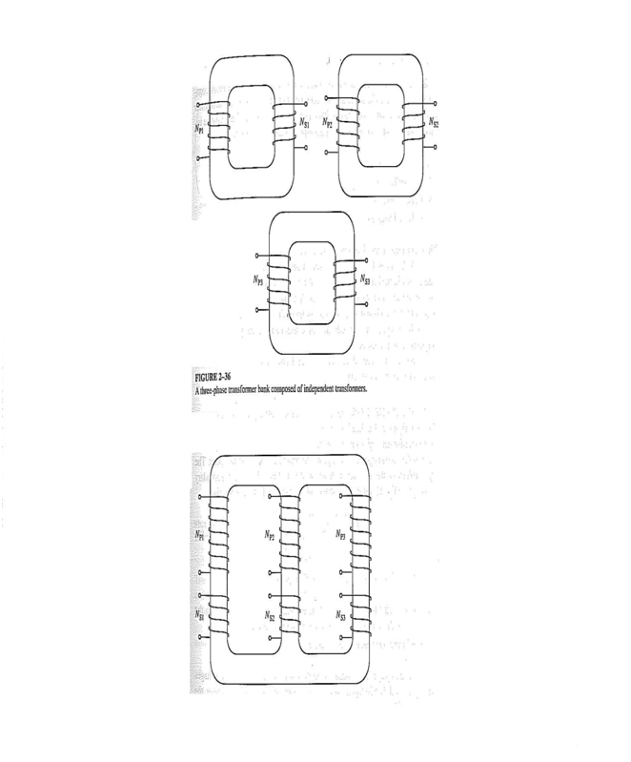

There are 4 main connections of 3-phase transformers:
1- Wye -Wye (Y-Y)

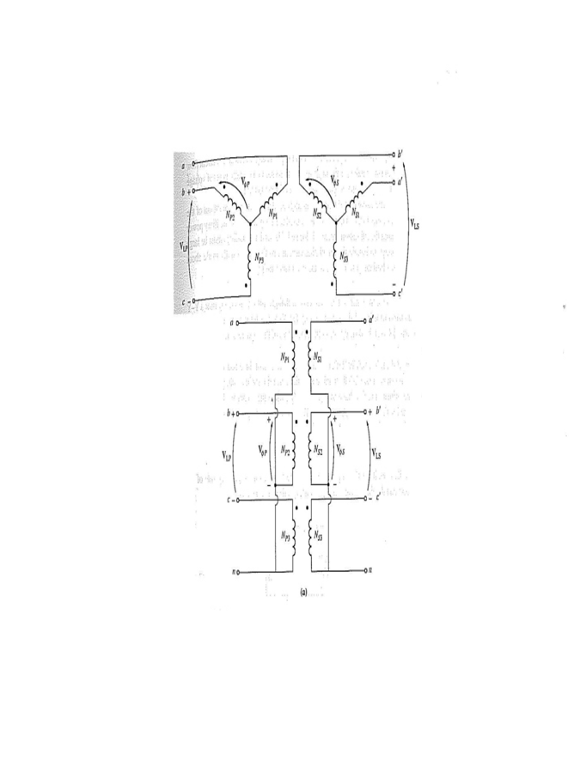
$$for Y- Y: \frac{V_{LP}}{V_{LS}}=\frac{{\sqrt{3}V}_{ΦP}}{\sqrt{3}V_{ΦS}}=a where\frac{V_{ΦP}}{V_{ΦS}}=a$$
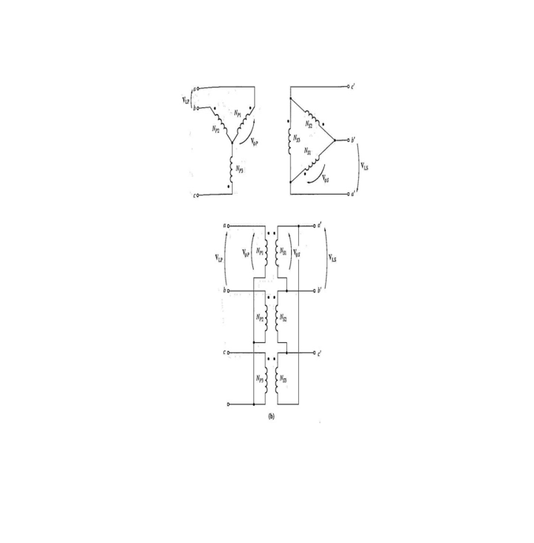
2- Wye-Delta (Y- Δ)

$$for Y- Δ: \frac{V_{LP}}{V_{LS}}=\frac{{\sqrt{3}V}_{ΦP}}{V_{ΦS}}=\sqrt{3}a where\frac{V_{ΦP}}{V_{ΦS}}=a$$

4-Delta-Delta (Δ- Δ)
3-Delta-Wye (Δ-Y)
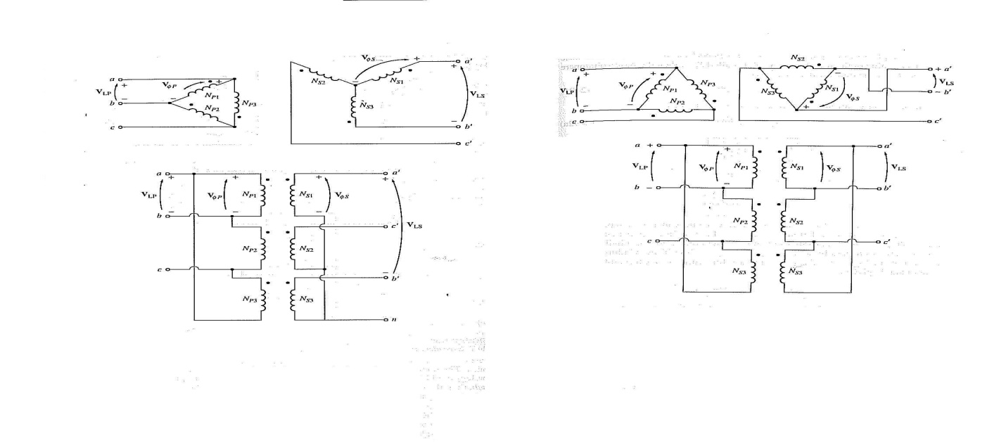

$$for Δ-Y: \frac{V_{LP}}{V_{LS}}=\frac{V_{ΦP}}{\sqrt{3}V_{ΦS}}=\frac{a}{\sqrt{3} } where\frac{V_{ΦP}}{V_{ΦS}}=a$$

$$for Δ-Δ: \frac{V_{LP}}{V_{LS}}=\frac{V_{ΦP}}{V_{ΦS}}=a where\frac{V_{ΦP}}{V_{ΦS}}=a$$

Remark: For each transformer:

$$For Y, V_{Φ}=\frac{V_{L}}{\sqrt{3}} and I_{Φ}=I_{L}$$
$$For Δ, V_{Φ}=V_{L} and I_{Φ}=\frac{I_{L}}{\sqrt{3}}$$

$$NB. Whenever we are dealing with a 3- Φ device, the given voltage is always$$
$$the line voltage unless otherwise stated.$$

Example

A 3-Φ bank of transformers in a power system is used to step up the voltage of 13.8 kV 3-Φ generator to 138 kV transmission line. The generator rating is 41.5 MVA.
Specify the voltage, current, the MVA rating of each transformer and establish the table of operating condition for Y-Y, Y-Δ, Δ-Y, Δ-Δ.

$$PRIMARY$$ |  |  |  | $$SECONDARY$$
 | $$V(kV)$$ | $$I(A)$$ | $$S(MVA)$$ |  | $$V(kV)$$ | $$I(A)$$ | $$S(MVA)$$
$$Y- Y$$ | 7.97 | 1736 | 13.83 |  | 79.67 | 173.6 | 13.83
$$Y- Δ$$ | 7.97 | 1736 | 13.83 |  | 138 | 100.2 | 13.83
$$Δ-Y$$ | 13.8 | 1002 | 13.83 |  | 79.67 | 173.6 | 13.83
$$Δ-Δ$$ | 13.8 | 1002 | 13.83 |  | 138 | 100.2 | 13.83

$$For Y, V_{Φ}=\frac{V_{L}}{\sqrt{3}} and I_{Φ}=I_{L}$$
$$For Δ, V_{Φ}=V_{L} and I_{Φ}=\frac{I_{L}}{\sqrt{3}}$$

$$In Y-Y, V_{P}=13.8 kV and V_{S}=138 kV$$
$$3-Φ generator=41.5 MVA rated$$
$$V_{ΦP}=\frac{13.8}{\sqrt{3}}=7.97 kV$$
$$V_{ΦS}=\frac{138}{\sqrt{3}}=79.67 kV$$
$$S_{P}=S_{S}=\frac{41.5}{3}=13.83 MVA$$
$$I_{ΦP}=\frac{13.83×{10}^{6}}{7.96×{10}^{3}}=736 A$$
$$I_{ΦS}=\frac{13.83×{10}^{6}}{79.67×{10}^{3}}=173.6 A$$

$$In Y-Δ$$
$$V_{ΦP}=\frac{13.8}{\sqrt{3}}=7.97 kV$$
$$V_{ΦS}=V_{LS}=138 kV$$
$$S=13.83 MVA (remains the same)$$
$$I_{P}=\frac{S_{Φ}}{V_{ΦP}}=\frac{13.83×{10}^{6}}{7.96×{10}^{3}}=736 A$$
$$I_{ΦS}=\frac{S_{Φ}}{V_{ΦS}}=\frac{13.83×{10}^{6}}{138×{10}^{3}}=100.21 A$$

$$In Δ-Δ, we {don}^{'}t use it because on high voltage side we use alot of extra insulation.$$
$$We use the Δ to damp the harmonic, no need anymore to stick in a tertiary winding.$$

